

NPTEL Online Certification Course
Industrial Engineering and Operations Research
Assignment Number 9: Detailed Solution
Indian Institute of Technology Guwahati

Q.1. Factories X and Y make 800 and 1000 units of a product, respectively. Units are supplied to 4 distributors, each requiring 500 units. To make it a balanced transportation problem,
(A) add a dummy destination requiring 200 units.
(B) modify the demand of each distributor to 400 units.
(C) add a dummy factory producing 200 units.
(D) add three dummy factories
Sol.
Supply:
Factory X = 800 units
Factory Y = 1000 units
Total supply = 800 + 1000 =1800 units
Demand:
Total demand = 4 × 500 = 2000 units
Hence, demand (2000) > supply (1800).
Shortage = 2000 – 1800 = 200.
To balance, add a dummy factory (supply) producing 700 units. Hence, option (C) is correct.
Q.2. A transportation problem (TP), in which the demand is equal to available resource, is called
(A) regular TP
(B) optimal TP
(C) unbalanced TP
(D) balanced TP
Sol. When total supply (available resource) = total demand, the transportation problem (TP) is called a balanced TP. Hence, option (D) is correct.
Q.3. In a balanced transportation problem with m supply points and n demand points, which of the following is always TRUE about the number of non-zero basic variables in a basic feasible solution (BFS)?
(A) A BFS always has exactly (m + n) non-zero basic variables.
(B) A BFS has more than (m + n − 1) non-zero basic variables.
(C) A BFS has at most (m + n − 1) non-zero basic variables.
(D) A degenerate BFS must have exactly (m + n −1) non-zero basic variables.
Sol. In a balanced transportation problem with m supply points and n demand points, any basic feasible solution (BFS) can have at most m + n −1 non-zero basic variables; if it has exactly m + n −1, the solution is non-degenerate, whereas fewer than m + n −1 non-zero basic variables indicate degeneracy. Hence, option (C) is correct.
Q.4. For a balanced transportation problem, which of the following statements is the most appropriate?
(A) A feasible solution may not exist.
(B) An optimal solution may not exist.
(C) An optimal solution always exists.
(D) There are always multiple optimal solutions.
Sol. In a balanced transportation problem, feasibility is guaranteed and the problem is bounded; therefore, an optimal solution always exists. However, the solution need not be unique—ties in cost or degeneracy can lead to multiple optima. At the same time, multiple optimal solutions are not guaranteed either, as in many cases the problem can have a unique optimum depending on the cost structure and the supply–demand arrangement. Hence, option (C) is correct.
Q.5. Three factories S1, S2, and S3 produce 25 kg, 30 kg, and 35 kg of some chemical, respectively. Destinations D1, D2, and D3 need 30 kg, 27 kg, and 33 kg of chemical, respectively. Per kg cost of transportation (in thousand rupees) are provided in the matrix. For example, transporting 1 kg of chemical from S1 to D1 will cost ₹4000.
 | D1 | D2 | D3 | Supply
S1 | 4 | 3 | 7 | 25
S2 | 5 | 6 | 8 | 30
S3 | 6 | 4 | 5 | 35
Demand | 30 | 27 | 33

The Northwest corner method provides the total transportation cost as
(A) ₹3,68,000 (B) ₹3,80,000 (C) ₹4,42,000 (D) ₹4,48,000
Sol. Total number of supply constraints: 3
Total number of demand constraints: 3
Problem table is

 | D1 | D2 | D3 | Supply
S1 | 4 | 3 | 7 | 25
S2 | 5 | 6 | 8 | 30
S3 | 6 | 4 | 5 | 35
Demand | 30 | 27 | 33
Here total demand (90) is equal to the total supply (90), meaning the model is balanced.
Start from the northwest corner cell (S1, D1). Check corresponding supply (25) and demand (30) values. The smaller of the two, i.e., min (25, 30) = 25 is assigned to (S1, D1). This exhausts the capacity of S1 (cross out the row S1) and leaves 30 – 25 = 5 units with D1.
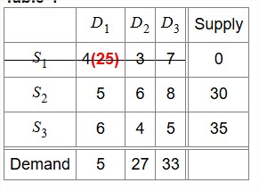
The next northwest corner cell is (S2, D1). Check corresponding supply (30) and demand (5) values. The smaller of the two, i.e., min (30, 5) = 5 is assigned to (S2, D1). This meets the complete demand of D1 (cross out column D1) and leaves 30 – 5 = 25 units with S2.
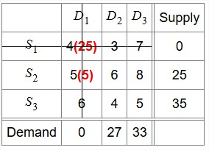
The next northwest corner cell is (S2, D2). Check corresponding supply (25) and demand (27) values. The smaller of the two, i.e., min (25, 27) = 25 is assigned to (S2, D2). This exhausts the capacity of S2 (cross out row S2) and leaves 27 – 25 = 2 units with D2.
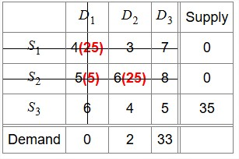
The next northwest corner cell is (S3, D2). Check corresponding supply (35) and demand (2) values. The smaller of the two, i.e., min (35, 2) = 2 is assigned to (S3, D2). This meets the entire demand of D2 (cross out column D2) and leaves 35 – 2 = 33 units with S3.
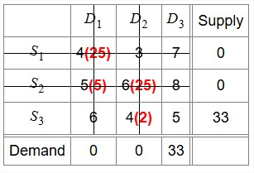
The last cell is (S3, D3). Check corresponding supply (33) and demand (33) values. Both supply and demand are equal. Thus, 33 is assigned to (S3, D3). This exhausts the capacity of S3 (cross out row S3) and meets the entire demand of D3 (cross out column D3).
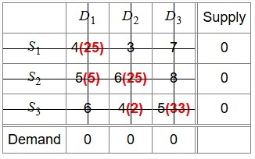
Final initial allocation is obtained. The initial feasible solution is
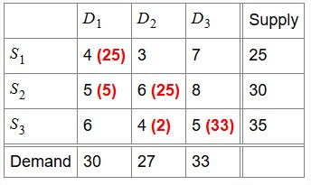
Total transportation cost = (4× 25 + 5 × 5 + 6 × 25 + 4 × 2 + 5× 33) × 1000 = ₹4,48,000.
Hence, option (D) is correct.
Q.6. Which of the following statements about the Northwest Corner Method (NWCM) for solving a balanced transportation problem is TRUE?
(A) NWCM provides an initial basic feasible solution with exactly (m + n −1) non-zero allocations.
(B) NWCM always gives the optimal solution for balanced transportation problems.
(C) NWCM ignores cost coefficients during allocation and may lead to a non-optimal starting solution.
(D) NWCM ensures minimum total transportation cost when the cost matrix is non-symmetric.
Sol.
Statement A: FALSE — NWCM usually produces up to m + n −1 non-zero allocations, but can yield fewer than m + n −1 (degeneracy) depending on supplies/demands and tie choices.
Statement A: FALSE — NWCM does not guarantee optimality. It provides a starting (basic feasible) solution that may not be optimal.
Statement C: TRUE — NCWM provides a starting (basic feasible) solution by making allocations starting from the northwest corner cell (route), regardless of the cost. Thus, NWCM ignores cost coefficients while making allocations, and the starting solution may not be optimal.
Statement D: FALSE — symmetry of the cost matrix does not ensure NWCM provides minimum total transportation cost.
Hence, option (C) is correct.
Q.7. Three factories F1, F2, and F3, manufacture 7, 2, and 10 machines in a month, respectively. There is a demand of 5, 4, 7, and 1 machines per month in cities C1, C2, C3, and C4, respectively. The cost (in thousand rupees) of shipping one machine from each factory to each city is given as follows:
 | C1 | C2 | C3 | C4
F1 | 3 | 2 | 11 | 7
F2 | 1 | 4 | 6 | 1
F3 | 5 | 8 | 15 | 9

Northwest corner initial solution provides total transportation cost as
(A) ₹1,00,000 (B) ₹1,77,000 (C) ₹1,41,000 (D) ₹1,95,000
Sol.
Total number of supply constraints: 3
Total number of demand constraints: 4
Problem table is

 | C1 | C2 | C3 | C4 | Supply
F1 | 3 | 2 | 11 | 7 | 7
F2 | 1 | 4 | 6 | 1 | 2
F3 | 5 | 8 | 15 | 9 | 10
Demand | 5 | 4 | 7 | 1
Here total demand = 17 is less than total supply = 19, meaning the model is unbalanced. Hence, a dummy city must be added to restore balance.
Hence, a dummy city with 0 unit cost and a demand constraint with allocation (19 – 17) = 2 is added. Now the modified table is
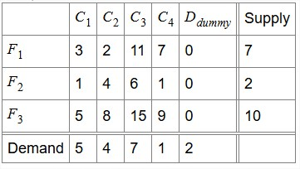
Start from the northwest corner cell (F1, C1). Check corresponding supply (7) and demand (5) values. The smaller of the two, i.e., min (7, 5) = 5 is assigned to (F2, C2). Both the supply and demand are equal. Thus, 5 is assigned to (F1, C1). This meets the complete demand of C1 and leaves 7–5=2 units with F1.
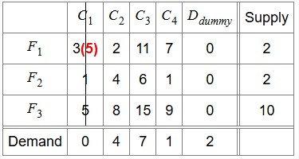
The next northwest corner cell (F1, C2). Check corresponding supply (2) and demand (4) values. The smaller of the two, i.e., min (2, 4) = 2 is assigned to (F1, C2). This exhausts the capacity of F1 (cross out row F1) and leaves 4 – 2 = 2 units with C2.
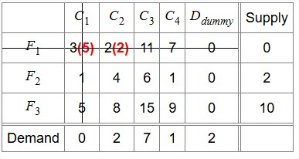
The next northwest corner cell (F2, C2). Check corresponding supply (2) and demand (2) values. The smaller of the two, i.e., min (2, 2) = 2 is assigned to (F2, C2). This meets the entire demand of C2 (cross out column C2) and leaves 2 – 2 = 0 units with F2.

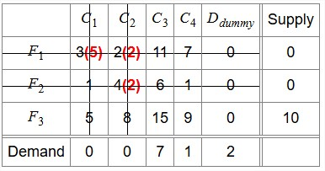
The next northwest corner cell (F3, C3). Check corresponding supply (10) and demand (7) values. The smaller of the two, i.e., min (10, 7) = 7 is assigned to (F3, C3). This meets the entire demand of C3 (cross out column C3) and leaves 10 – 7 = 3 units with F3.
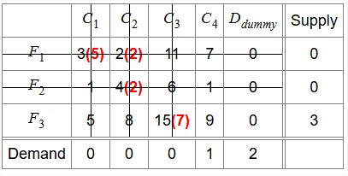
The next northwest corner cell (F3, C4). Check corresponding supply (3) and demand (1) values. The smaller of the two, i.e., min (3, 1) = 1 is assigned to (F3, C4). This meets the entire demand of C4 (cross out column C4) and leaves 3 – 1 = 2 units with F3.
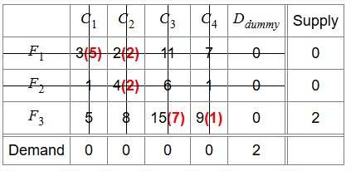
The last northwest corner cell (F3, D_{dummy}) is left. Check corresponding supply (2) and demand (2) values. Thus, 2 is assigned to (F3, D_{dummy}). This exhausts the capacity of F3 (cross out row F3) and meets the entire demand of D_{dummy} (cross out column D_{dummy}).

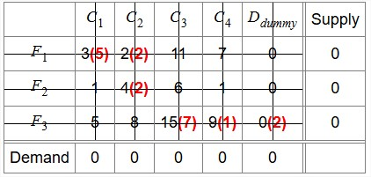
The final initial allocation is reached. The initial feasible solution is
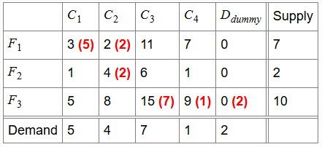
Total transportation cost = (3 × 5 + 2 × 2 + 4 × 2 + 15 × 7 + 9 × 1 + 0 × 2) × 1000 = ₹1,41,000.
Hence, option (C) is correct.
Q.8. There are 10 factories supplying goods to 20 distributors. Total supply is 4000 units, whereas demand is 5000 units, which means the demand of 1000 units cannot be met. For the transportation model, the Northwest corner method is used for obtaining the initial basic feasible solution. The number of basic variables is
(A) 30 (B) 20 (C) 32 (D) 31
Sol. Given m = 10 factories (sources) and n = 20 distributors (destinations).
Since supply (= 4000 units) < demand (= 5000 units), the problem is unbalanced.
A dummy source of supply 1000 has to be added to balance supply and demand.
Thus, the balanced problem has m′ = 10 + 1 = 11 sources and n = 20 destinations.
For a transportation problem, the number of basic variables in a basic feasible solution is
m′ + n −1 = 11 + 20 −1 = 30.
Hence, option (A) is correct.
Q.9. Which one of the following statements about the Least Cost Method (LCM) for solving a balanced transportation problem with m suppliers and n destinations is TRUE?
(A) LCM always provides the optimal solution when the total supply equals total demand.
(B) LCM allocates as much as possible to the lowest-cost cell and ensures minimum transportation cost.
(C) LCM guarantees a degenerate basic feasible solution with fewer than (m + n −1) allocations.
(D) LCM considers cost coefficients in allocation and generally gives a better initial feasible solution than the Northwest Corner method.
Sol. Statement (A): FALSE — LCM does not always provide the optimal solution; it only gives an initial basic feasible solution. Optimality still requires checking (e.g., MODI optimality test/stepping stone).
Statement (B): FALSE — LCM does allocate starting from the lowest-cost cells, but it does not ensure minimum transportation cost.
Statement (C): FALSE — LCM does not guarantee a degenerate basic feasible solution; degeneracy can happen in any method.
Statement (D): TRUE — LCM takes costs into account when constructing the initial solution, so it generally provides a better (lower cost) starting solution (initial feasible solution) compared to the Northwest Corner Method.
Hence, option (D) is correct.
Q.10. Three factories S1, S2, and S3 produce 30 kg, 35 kg, and 20 kg of some chemical, respectively. Destinations D1, D2, and D3 need 25 kg, 35 kg, and 25 kg of chemical, respectively. Per kg cost of transportation (in thousand rupees) is provided in the matrix. For example, transporting 1 kg of chemical from S1 to D1 will cost ₹3000.
 | D1 | D2 | D3 | Supply
S1 | 3 | 6 | 8 | 30
S2 | 5 | 4 | 7 | 35
S3 | 6 | 4 | 5 | 20
Demand | 25 | 35 | 25

The Least Cost method provides the total transportation cost as
(A) ₹3,75,000 (B) ₹3,55,000 (C) ₹2,65,000 (D) ₹1,95,000
Sol.
Total number of supply constraints: 3
Total number of demand constraints: 3
Problem table is
 | D1 | D2 | D3 | Supply
S1 | 3 | 6 | 8 | 30
S2 | 5 | 4 | 7 | 35
S3 | 6 | 4 | 5 | 20
Demand | 25 | 35 | 25

Here total demand (85) is equal to the total supply (85), meaning the model is balanced.
The least unit cost is 3 in cell (S1, D1). Check corresponding supply (30) and demand (25) values. The allocation to this cell is min (30, 25) = 25. This satisfies the entire demand of D1 (cross out column D1) and leaves 30 – 25 = 5 units with S1.
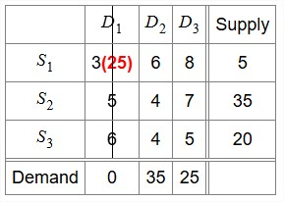
The next least unit cost is 4 in cells (S2, D2) and (S3, D2). As there is a tie, the cell (S2, D2) is first chosen. Check corresponding supply (35) and demand (35) values. The allocation to this cell is min (35, 35) = 35. This exhausts the capacity of S2 (cross out row S2) and D2 (cross out D2).
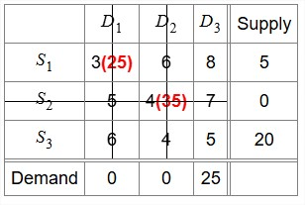
The next least unit cost is 5 in cell (S3, D3). Check corresponding supply (20) and demand (25) values. The allocation to this cell is min (20, 25) = 20. This satisfies the entire demand of S3 (cross out row S3) and leaves 25 – 20 = 5 units with S3.
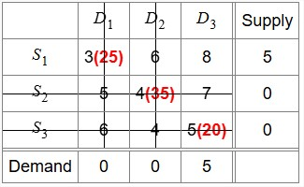
The next least unit cost is 8 in cell (S1, D3). Check corresponding supply (5) and demand (5) values. The allocation to this cell is min (5, 5) = 5. This exhausts the capacity of S1 (cross out row S1) and leaves 5 – 5 = 0 units with D3.
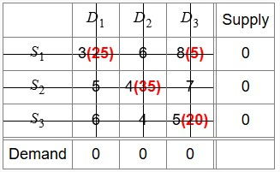
The initial feasible solution is
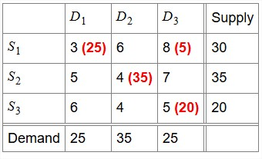
Total transportation cost = (3 × 25 + 8 × 5 + 4 × 35 + 5 × 20) × 1000 = ₹3,55,000. Hence, option (B) is correct.
Q.11. In a balanced transportation problem with m sources and n destinations, the Least Cost Method (LCM) is used to find the initial basic feasible solution. Consider the following statements:
1. The LCM always yields a solution with exactly m + n −1 non-zero allocations, even when multiple cells have the same least cost.
2. The LCM always provides a higher total cost initial solution than the Northwest Corner Method (NWCM).
3. If the least-cost allocation is made greedily at each step without breaking ties optimally, the resulting solution may be degenerate.
4. The number of different initial solutions that can be generated by LCM depends on the tie-breaking strategy.
Which of the above statements are TRUE?
(A) 1, 2, and 3
(B) 2 and 4 only
(C) 3 and 4 only
(D) All four statements are true
Sol.
Statement (1): FALSE — LCM does not always produce exactly m + n −1 non-zero allocations; ties in the least cost can lead to fewer than m + n −1 allocations (degeneracy).
Statement (2): FALE — LCM usually gives a better (lower-cost) initial solution than the Northwest Corner Method (NWCM), but it does not guarantee a strictly lower total cost in every instance.
Statement (3): TRUE — Greedy least-cost allocations with arbitrary tie-breaking may allocate in such a way that certain rows/columns get completely exhausted too early, potentially blocking allocations that could be made later. This can lead to situations where the method does not allocate enough supplies to meet the m + n −1 requirement, creating a degenerate solution.
Statement (4): TRUE — In LCM, when there are multiple cells with the same minimum cost, different tie-breaking strategies can lead to different allocations and, subsequently, different initial feasible solutions. The sequence of allocations made in the initial steps can influence the total supply and demand remaining for subsequent steps, thereby affecting the overall pattern of the initial solution.
Hence, option (C) is correct.

Q.12. Three factories F1, F2, and F3 manufacture 5, 2, and 10 machines in a month, respectively. There is a demand of 5, 4, 3, and 1 machines per month in cities C1, C2, C3, and C4, respectively. The cost (in thousand rupees) of shipping one machine from each factory to each city is given as follows:
 | C1 | C2 | C3 | C4
F1 | 1 | 2 | 6 | 1
F2 | 1 | 3 | 11 | 7
F3 | 5 | 8 | 15 | 9

Least Cost initial solution provides the total transportation cost as
(A) ₹84,000 (B) ₹79,000 (C) ₹81,000 (D) ₹73,000
Sol.
Total number of supply constraints: 3
Total number of demand constraints: 4
Problem table is

 | C1 | C2 | C3 | C4 | Supply
F1 | 1 | 2 | 6 | 1 | 5
F2 | 1 | 3 | 11 | 7 | 2
F3 | 5 | 8 | 15 | 9 | 10
Demand | 5 | 4 | 3 | 1
Here total demand = 13 is less than total supply = 17, meaning the model is unbalanced. Hence, a dummy city must be added to restore balance.
Hence, add a dummy city with 0 unit cost and a demand constraint with allocation (17 – 13) = 4. First allocate cells except dummy column and at last step in dummy column.
Now the modified table is
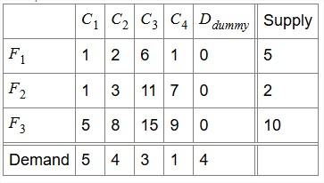
The least unit cost is 1 in cells (F1, C1), (F1, C4) and (F2, C1). Since there is a tie, select the cell (F1, C1). Check corresponding supply (5) and demand (5) values. The allocation to this cell is min (5, 5) = 5. This exhausts the capacity of F1 and C1.
 | C1 | C2 | C3 | C4 | D_{dummy} | Supply
F1 | 1(5) | 2 | 6 | 1 | 0 | 0
F2 | 1 | 3 | 11 | 7 | 0 | 2
F3 | 5 | 8 | 15 | 9 | 0 | 10
Demand | 0 | 4 | 3 | 1 | 4

The next least unit cost is 3 in cell (F2, C2). Check corresponding supply (2) and demand (4) values. The allocation to this cell is min (2, 4) = 2. This meets the complete demand of F2 (cross out row F2) and leaves 4 – 2 = 2 unit with F2.
 | C1 | C2 | C3 | C4 | D_{dummy} | Supply
F1 | 1(5) | 2 | 6 | 1 | 0 | 0
F2 | 1 | 3(2) | 11 | 7 | 0 | 0
F3 | 5 | 8 | 15 | 9 | 0 | 10
Demand | 0 | 2 | 3 | 1 | 4
The next least unit cost is 8 in cell (F3, C2). Check corresponding supply (10) and demand (2) values. The allocation to this cell is min (10, 2) = 2. This exhausts the capacity of C2 (cross out column C2) and leaves 10 – 2 = 8 units with F3.
 | C1 | C2 | C3 | C4 | D_{dummy} | Supply
F1 | 1(5) | 2 | 6 | 1 | 0 | 0
F2 | 1 | 3(2) | 11 | 7 | 0 | 0
F3 | 5 | 8(2) | 15 | 9 | 0 | 8
Demand | 0 | 0 | 3 | 1 | 4

The next least unit cost is 9 in cell (F3, C4). Check corresponding supply (8) and demand (1) values. The allocation to this cell is min (8, 1) = 1. This meets the complete demand of C4 (cross out column C2) and leaves 8 – 1 = 7 units with F3.
 | C1 | C2 | C3 | C4 | D_{dummy} | Supply
F1 | 1(5) | 2 | 6 | 1 | 0 | 0
F2 | 1 | 3(2) | 11 | 7 | 0 | 0
F3 | 5 | 8(2) | 15(3) | 9(1) | 0 | 4
Demand | 0 | 0 | 0 | 0 | 4
The next least unit cost is in cell (F3, D_{dummy}). Check corresponding supply (6) and demand (6) values. The allocation to this cell is min (6, 6) = 6. This meets the complete demand of Ddummy and F3.
 | C1 | C2 | C3 | C4 | D_{dummy} | Supply
F1 | 1(5) | 2 | 6 | 1 | 0 | 0
F2 | 1 | 3(2) | 11 | 7 | 0 | 0
F3 | 5 | 8(2) | 15(3) | 9(1) | 0(4) | 0
Demand | 0 | 0 | 0 | 0 | 0
Initial feasible solution is
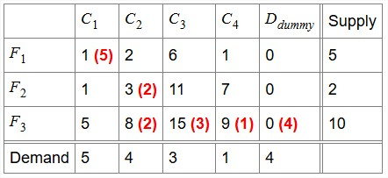

Total transportation cost = (1 × 5 + 3 × 2 + 8 × 2 + 15 × 3 + 9 × 1 + 0 × 4) × 1000 = ₹81,000.
Hence, option (C) is correct.
Q.13. Which one of the following statements about Vogel’s Approximation Method (VAM) for solving a balanced transportation problem with m suppliers and n destinations is TRUE?
(A) VAM gives the optimal solution by allocating as much as possible to the cell with the lowest cost cells.
(B) VAM guarantees that the number of positive allocations will always be equal to m + n.
(C) VAM ignores cost coefficients and follows a strict upper-left corner allocation pattern.
(D) VAM generally provides a better initial basic feasible solution than both the Northwest Corner and Least Cost methods.
Sol.
Statement (A): FALSE — VAM does not guarantee the optimal solution; it only gives an initial basic feasible solution by using penalties (difference between the two lowest costs in a row/column). Optimality must still be checked (e.g., using MODI method).
Statement (B): FALSE — For a transportation problem, a non-degenerate basic feasible solution should have exactly m + n −1 positive allocations. VAM provides an initial basic feasible solution but does not guarantee non-degeneracy. In certain cases, VAM may yield fewer than m + n −1 positive allocations, which need to be modified to find the optimal solution.
Statement (C): FALSE — The statement describes the Northwest Corner Method (NWCM), not VAM.
Statement (D): TRUE — VAM explicitly considers cost penalties, so in practice it produces an initial basic feasible solution closer to optimal than the Northwest Corner and Least Cost methods.
Hence, option (D) is correct.
Q.14. Three factories S1, S2, and S3 produce 35 kg, 30 kg, and 20 kg of some chemical, respectively. Destinations D1, D2, and D3 need 25 kg, 35 kg, and 25 kg of chemical, respectively. Per kg cost of transportation (in thousand rupees) are provided in the matrix. For example, transporting 1 kg of chemical from S1 to D1 will cost ₹5000.
 | D1 | D2 | D3 | Supply
S1 | 5 | 3 | 7 | 35
S2 | 4 | 6 | 8 | 30
S3 | 6 | 4 | 5 | 20
Demand | 25 | 35 | 25
The Vogel Approximation method provides the total transportation cost as
(A) ₹2,65,000 (B) ₹3,65,000 (C) ₹2,85,000 (D) ₹3,45,000
Sol.
Total number of supply constraints: 3
Total number of demand constraints: 3
Problem table is
 | D1 | D2 | D3 | Supply
S1 | 5 | 3 | 7 | 35
S2 | 4 | 6 | 8 | 30
S3 | 6 | 4 | 5 | 20
Demand | 25 | 35 | 25

Here total demand (85) is equal to the total supply (85). Hence, the model is balanced. For each row (column), determine a penalty measure by subtracting the smallest unit cost in the row (column) from the next smallest unit cost in the same row (column).
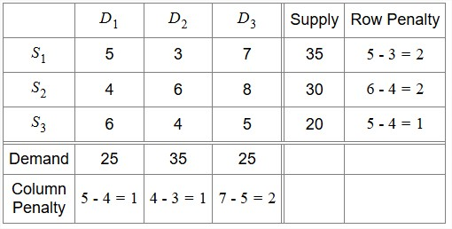
Identify the row or column with the largest penalty. Allocate as much as possible to the cell with the least unit cost in the selected row or column. The maximum penalty (2) is in rows S1 and S2, and column D3. Row S1 has the least unit cost, 3. Hence, this cell is chosen first. The maximum allocation in this cell (S1, D1) is min (35, 35) = 35. This meets the demand of S1 and D2. Cross out row S1 and column D2.

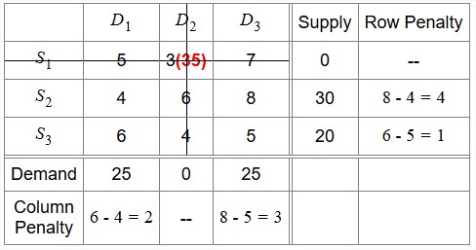
The next maximum penalty (4) is in row S2, and the corresponding least unit cost is 4. The maximum allocation in this cell (S2, D1) is min (30, 25) = 25. This exhausts the capacity of D1 (cross out column D1) and leaves 30 – 25 = 5 units with S2.
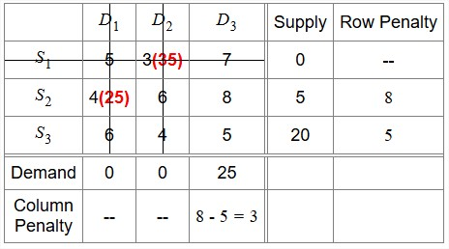
The next maximum penalty (8) is in row S2. The least unit cost is 8 The maximum allocation in this cell (S3, D3) is min (5, 25) = 55. This meets the entire demand of S2 (cross out row S2) and leaves 25 – 5 = 20 units with D3.
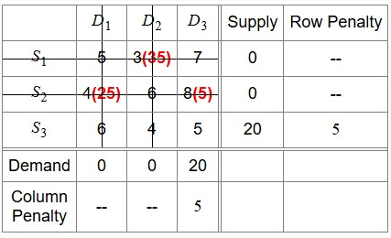
The next maximum penalty (5) is in row S3, and the corresponding least unit cost is 5. The maximum allocation in this cell (S3, D3) is min (20, 20) = 20. It satisfies supply of S3 and demand of D3. The initial basic feasible solution is
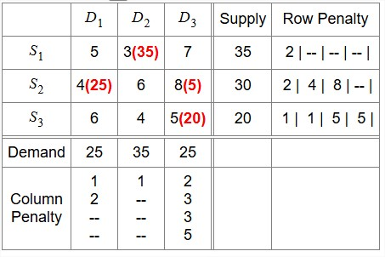
The minimum total transportation cost = (3 × 35 + 4 × 25 + 8 × 5 + 5 ×20) × 1000 = ₹3,45,000.
Hence, option (D) is correct.
Q.15. Three factories F1, F2, and F3 manufacture 7, 2, and 10 machines in a month, respectively. There is a demand of 6, 4, 3, and 1 machines per month in cities C1, C2, C3, and C4, respectively. The cost (in thousand rupees) of shipping one machine from each factory to each city is given as follows:
 | C1 | C2 | C3 | C4
F1 | 1 | 2 | 6 | 1
F2 | 2 | 3 | 11 | 7
F3 | 5 | 8 | 15 | 9

Vogel Approximation method provides total transportation cost as
(A) ₹65,000 (B) ₹75,000 (C) ₹55,000 (D) ₹85,000
Sol.
Total number of supply constraints: 3
Total number of demand constraints: 4
Problem table is
 | C1 | C2 | C3 | C4 | Supply
F1 | 1 | 2 | 6 | 1 | 7
F2 | 2 | 3 | 11 | 7 | 2
F3 | 5 | 8 | 15 | 9 | 10
Demand | 6 | 4 | 3 | 1
Here total demand = 14 is less than total supply = 19, meaning the model is unbalanced. Hence, a dummy city must be added to restore balance.
Hence, add a dummy city with 0 unit cost and a demand constraint with allocation (19 – 14) = 5.
Now the modified table is
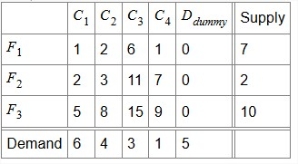
For each row (column), determine a penalty measure by subtracting the smallest unit cost in the row (column) from the next smallest unit cost in the same row (column).
For example, for row F1, the smallest unit cost is 0 and the next smallest unit cost is 1. Row penalty is 1 – 0 = 1. Similarly, for column C1, the smallest unit cost is 1 and the next smallest unit cost is 2. Column penalty is 2 – 1 = 1.
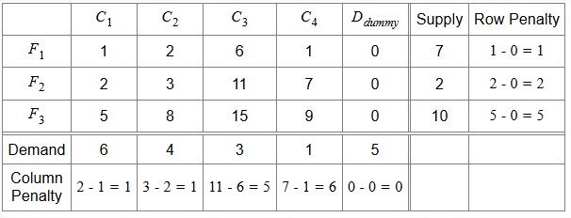
Identify the row or column with the largest penalty. Allocate as much as possible to the cell with the least unit cost in the selected row or column. The maximum penalty (6) is in column C4, and the corresponding least unit cost is 1. The maximum allocation in this cell (F1, C4) is min (7, 1) = 1. This exhausts the capacity of C4.
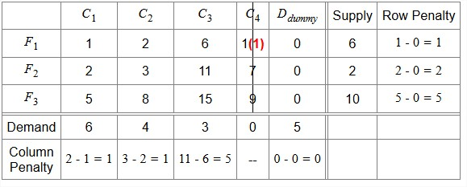

The next maximum penalty (5) is in row F3 and column C3, and the corresponding least unit cost is 0 and 6, respectively. Choose the row F3 with unit cost 0. The maximum allocation in this cell (F3, D_{dummy}) is min (5, 5) = 5. This satisfies the entire demand of D_{dummy} and F3.
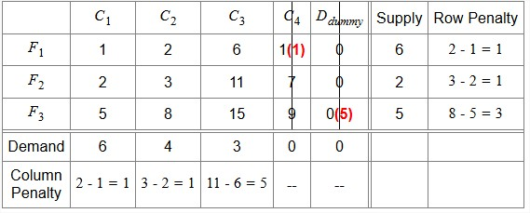
The next maximum penalty (5) is in column C3, and the corresponding least unit cost is 6.
The maximum allocation in this cell (F1, C3) is min (6, 3) = 3. This satisfies the entire demand of C3 (cross out column C3) and leaves 6 – 3 = 3 units with F1.
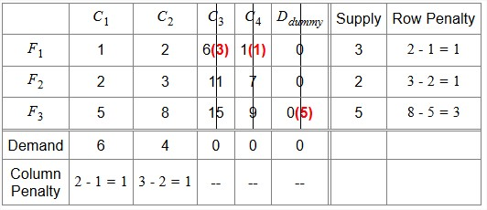
The next maximum penalty (3) is in row F3, and the corresponding least unit cost is 5.
The maximum allocation in this cell (F3, C1) is min (5, 6) = 5. This exhausts the capacity of F3 (cross out row F3).
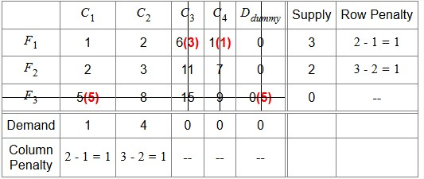
The next maximum penalty (1) is in row F1 with the cell (F1, C1). The maximum allocation in this cell is min (3, 1) = 1. This exhausts the capacity of C1 (cross out column C1) and leaves 3 – 1 = 2 units with F1.
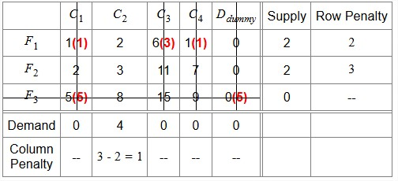
The next maximum penalty (3) is in row F2 with the cell (F1, C1). The maximum allocation in this cell is min (2, 4) = 2.
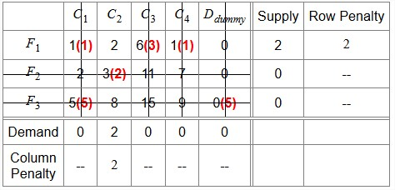
The next maximum penalty (2) is in row F1. The maximum allocation in this cell is min (2, 2) = 2. The final initial allocation. The initial feasible solution is
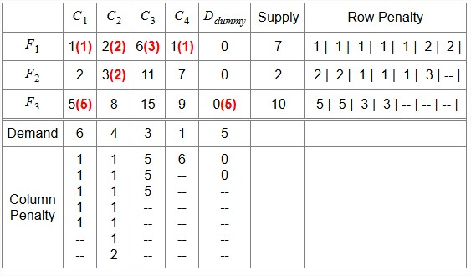
The minimum total transportation cost = (1 × 1 + 2 × 2 + 6 × 3 + 1 × 1 + 3 × 2 + 5 × 5 + 0 × 5 ) × 1000 = ₹55,000.
Hence, option (C) is correct.
Q.16. In a balanced transportation problem with m sources and n destinations, the Vogel Approximation Method (VAM) is used to find the initial basic feasible solution. Consider the following statements:
1. The VAM always provides a lower total cost initial solution than the Northwest Corner Method (NWCM).
2. If the least-cost allocation is made greedily at each step without breaking ties optimally, the resulting solution may be degenerate.
3. The number of different initial solutions that can be generated by VAM depends on the tie-breaking strategy.
4. The VAM always yields a solution with exactly m + n −1 non-zero allocations, even when multiple cells have the same least cost.
Which of the above statements are TRUE?
(A) 1, 3, and 4
(B) 1 and 4 only
(C) 2 and 3 only
(D) All four statements are true
Sol.
Statement 1: FALSE — VAM considers penalty costs, which are the differences between the two lowest costs in each row and column, guiding allocations towards lower-cost routes. The NWCM, on the other hand, makes allocations based solely on position, starting from the northwest corner, without considering costs. Thus, VAM generally gives a better starting solution than NWCM, but does not guarantee a strictly lower cost in every case.
Statement 2: TRUE — Greedy least-cost choices with arbitrary tie-breaking can exhaust rows/columns too early and produce a degenerate solution.
Statement 3: TRUE — Tie-breaking choices in VAM can lead to different allocation sequences and thus different initial feasible solutions. When multiple rows or columns have the same highest penalty, or when multiple cells within a chosen row or column have the same least cost, the choice of which to select can lead to different allocation paths and, consequently, different initial basic feasible solutions.
Statement 4: FALSE — When multiple cells have the same least cost (tie situations), the tie-breaking choice can sometimes exhaust supply or demand in a way that leaves fewer than m + n −1 route allocations (degeneracy). Since VAM is only a heuristic for generating an initial basic feasible solution, it does not guarantee non-degeneracy and can produce degenerate solutions.
Hence, option (C) is correct.

Q.17. Which of the following statements is TRUE about the MODI (Modified Distribution) method in transportation problems?
(A) It can only be applied if the cost matrix is symmetric.
(B) It is used to find an initial feasible solution when supply is equal to demand.
(C) It is used only when the transportation problem is unbalanced.
(D) It helps check optimality and improve the current solution.
Sol. The MODI (Modified Distribution) method is used to test the optimality of a basic feasible solution in a transportation problem. It does so by calculating the opportunity costs of unoccupied cells using dual variables (u and v). If all opportunity costs are non-negative, the current solution is optimal. However, if any opportunity cost is negative, the MODI method improves upon the current solution by creating a closed loop to adjust allocations until all opportunity costs are non-negative. This is repeated until all opportunity costs are non-negative, indicating the optimal solution is reached. Hence, option (D) is correct.
Q.18. The unit cost of transportation from supplier i to destination j is C_{ij}. The dual variable associated with the supplier i is u_{i} and that with destination j is v_{j}. In the optimized solution supplier i transports nothing to destination j. In that case,
(A) C_{ij} = u_{i} + v_{j} (B) C_{ij} ≥ u_{i} + v_{j} (C) C_{ij} < u _{i}+ v_{j} (D) C_{ij} > u_{i} + v_{j}
Sol. Since the supplier i transports nothing to destination j in the optimized solution, this route is unused. For an unused route, the actual transportation cost (C_{ij}) must be at least as large as the estimated cost given by u_{i} + v_{j}, i.e., C_{ij} ≥ u_{i} + v_{j}. Otherwise, using this route would reduce the total cost, contradicting optimality. Hence, option (B) is correct.
Q.19. Transportation costs per unit from three plants to two market places are as per the following matrix:
 | Market 1 | Market 2 | Supply
Plant 1 | ₹85 | ₹16 | 1100 units
Plant 2 | ₹100 | ₹108 | 1400 units
Plant 3 | ₹102 | ₹8 | 1200 units
Demand | 2200 units | 1500 units
The minimum total cost of transportation is
(A) ₹2,25,100 (B) ₹2,25,700 (C) ₹2,22,400 (D) ₹2,22,800
Sol.
Total number of supply constraints: 3
Total number of demand constraints: 2
Problem table is
 | Market 1 | Market 2 | Supply
Plant 1 | ₹85 | ₹16 | 1100 units
Plant 2 | ₹100 | ₹108 | 1400 units
Plant 3 | ₹102 | ₹8 | 1200 units
Demand | 2200 units | 1500 units

Here, total demand (3700) is equal to the total supply (3700), meaning the model is balanced. Initial feasible solutions can be obtained using either Northwest corner method, least cost method, or Vogel approximation method. Least cost method will be used for this problem.
Initial allocation using least cost method
The least unit cost is 8 in cell (Plant 3, Market 2). Check corresponding supply (1200) and demand (1500) values. The allocation to this cell is min (1200, 1500) = 1200. This exhausts the capacity of Plant 3 (cross out row Plant 3) and leaves 1500 – 1200 = 300 units with Market 2.
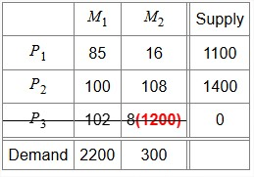
The next least unit cost is 16 in cell (Plant 1, Market 2). Check corresponding supply (1100) and demand (300) values. The allocation to this cell is min (1100, 300) = 300. This satisfies the entire demand of Market 2 (cross out column Market 2) and leaves 1100 – 300 = 800 units with Plant 1.
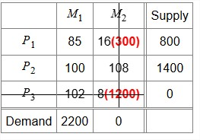
The next least unit cost is 8 in cell (Plant 1, Market 1). Check corresponding supply (800) and demand (2200) values. The allocation to this cell is min (800, 2200) = 800. This exhausts the capacity of Plant 1 (cross out row Plant 1) and leaves 2200 – 800 = 1400 units with Market 1.
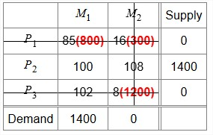
The next least unit cost is 100 in cell (Plant 2, Market 1). Check corresponding supply (1400) and demand (1400) values. The allocation to this cell is 1400. This exhausts the capacity of Plant 2 and Market 1.
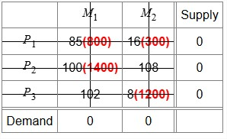
The initial feasible solution is
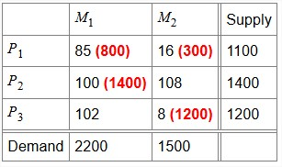
The minimum total transportation cost =85 × 800 + 16 × 300 + 100 × 1400 + 8 × 1200 = ₹2,22,400.

Optimality test

Start with the starting solution obtained using the least cost method.
Here, the no. of positive allocated cells (4) = m + n –1, where m = 3 (no. of rows) and n = 2 (no. of columns). Hence, this solution is non-degenerate.
Allocation table is
Find and 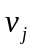 for all occupied cells (i, j), where 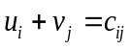(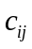is unit cell cost).

Basic variable | (u, v) equation | Solution
x₁₁ | u₁ + v₁ = 85 | Set u₁ = 0. Hence, v₁ = 85
x₂₁ | u₂ + v₁ = 100 | u₂ = 100 – 85 =15
x₁₂ | u₁ + v₂ = 21 | v₂ = 21 – 0 = 21
x₃₂ | u₃ + v₂ = 8 | u₃ = 8 – 21= –13
Find 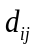 for all unoccupied cells (i, j), where 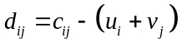
Non-basic variable
x₂₂ | d₂₂ = c₂₂ – (u₂ + v₂) = 108 – (15+21) = 72
x₃₁ | d₃₁ = c₃₁ – (u₃ + v₁) = 102 – (–13+88) = 27

Since d_{ij} ≥ 0 for all unoccupied cells (i, j), the solution is optimal, i.e., the initial feasible solution obtained using the least cost method is the optimal solution. The minimum total transportation cost is ₹2,22,400. Hence, option (C) is correct.
Q.20. One step of MODI method is shown in a transportation problem. Here, X units are added or subtracted in some cells.
 | Lucknow | Delhi | Jaipur | Chennai | Kolkata | D_{dummy} | Supply
Patna | 610(2000) | 1060(1000) | 1180 | 1490 | 580 | 0 | 3000
Guwahati | 1020 | 1910(6000 – X)  – | 1946 | 2700 | 1018 (X)  + | 0 | 6000
Mumbai | 1370 | 1420(0 + X)  + | 1150(4000 – X)  – | 1330 | 2050 | 0 | 4000
Hyderabad | 1300 | 1560 | 1470 (0 + X)  + | 630(1000) | 1500(2000 – X)  – | 0(3000) | 5000
Demand | 2000 | 7000 | 4000 | 1000 | 1000 | 3000

The value of X is
(A) 0 (B) 1000 (C) 2000 (D) 3000
Sol. In the MODI method, allocations are adjusted along a closed loop with alternating + and – signs.
- Along (+) cells → add X (increase allocation).
- Along (–) cells → subtract X (decrease allocation).
This way, total supply and demand remain satisfied (because what is added in one place, it is subtracted in another). Subtracting too much from a (–) cell would make its allocation negative, which is not allowed.
Looking at the table, the (–) cells have allocations of 2000, 4000, and 6000. The maximum that can be subtracted is limited by the smallest of these numbers, i.e., 2000. This ensures that at least one (–) cell becomes zero (cell with 2000 – X), and none becomes negative. That cell leaves the basis, while the unused entering cell (the one with the most negative opportunity cost, here cell with variable X) gets a positive value (=2000). Thus, the value of X is 2000. Hence, option (C) is correct.

